Capybara Health Check

User Satisfaction

|  |  |
| --- | --- |
|  | **Overall Sentiment**  How happy are you with the new solution? |
|  | **Usability**  How easy is the Capybara solution to use? |
|  | **Value**  How well does it help you do your work? |

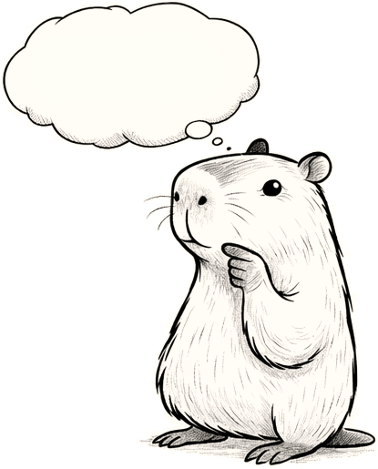

Open Question

Is there anything you’d

like to add (suggestions, etc.)?